DnD Character Creator

By Michal Staniewski

# Project Overview

This project will be a tool for creating a character for the board game Dungeons and Dragons. The tool will allow the player to:

* Choose the characters class.
* Choose characters race and customize appearance.
* Customize character stats such as strength, agility, magic, intelligence…
* Choose 3 base abilities depending on the characters race.

Visually, the character creator will be inspired by the character creator in the game Divinity Original Sin 2 and the characters, stats and races will be taken from the Dungeons and Dragons board game. The use will have access to several premade classes with their own stats and abilities. The player will be able to customize these classes as they wish. The player will be able to use these premade classes on any race they choose but each race will have some stat modifiers, for instance, the Dwarf race will have higher strength at the cost of lower agility and the elf race will have higher agility at the cost of lower strength. The classes and races will have their own backstories and details that the player can read about (these will be taken from the Dungeons and Dragons game).

The UI will be simple and inspired by the character creator in the game Divinity Original Sin 2. The player will interact with the UI by clicking on it to select different races and classes, then after selecting the desired class and race the player will be able to customize the stats of their character. The stats of the character will be displayed on the left of the character model and the customization UI will be on the left of the character. Above the character customization UI, there will be a tab that allows the player to change to the character appearance customization that allows the player to customize the characters appearance.

1. What is/are the game mechanics?

Ability to create and customize a DnD character

Ability to customize the characters appearance (not very complex)

Can choose a character race and character class both of which will affect the characters stats.

1. Who is the player?

The player is the designer of the character, they oversee the creation of their DnD character.

1. What is the story/point?

The point is to create a DnD character it is a character creator.

1. What will it look like?

The art will be simple, I will most likely use some low poly characters and simple assets.

# Character Classes and Races

## Races:

The player will choose one of these races for their character to be. Each race will have unique abilities that only that race will have access to. Each race also has unique strengths and weakness modifiers to the characters stats.

I took some of the races from the official Dungeons and Dragons game and modified their abilities to suit this project a little better.

|  |  |  |
| --- | --- | --- |
| *Race and stats* | *Abilities* | *Details and visuals* |
| Human  *Strength: 0*  *Movement: 0*  *Charm: 0*  *Intelligence: 0*  *Mystic: 0* | **Rallying Cry:** When you use your Second Wind feature, you can choose up to three creatures within 60 feet of you that are allied with you. Each one regains hit points equal to your fighter level, provided that the creature can see or hear you.  **Specialising:** You gain +1 to a stat of your choice | <https://www.dndbeyond.com/races/1-human> |
| Elf  *Strength: - 2*  *Movement: + 2*  *Charm: - 1*  *Intelligence: 0*  *Mystic: + 1* | **Mask of the Wild:** You can attempt to hide even when you are only lightly obscured by foliage, heavy rain, falling snow, mist, and other natural phenomena. | <https://www.dndbeyond.com/races/3-elf> |
| Ork  *Strength: + 3*  *Movement: 0*  *Charm: - 1*  *Intelligence: - 2*  *Mystic: 0* | **Relentless Endurance:** When you are reduced to 0 hit points but not killed outright, you can drop to 1 hit point instead. You can’t use this feature again until you finish a long rest. | <https://www.dndbeyond.com/races/2-half-orc> |
| Dwarf  *Strength: + 2*  *Movement: - 2*  *Charm: 0*  *Intelligence: 0*  *Mystic: 0* | **Dwarven Toughness:** Your hit point maximum increases by 1, and it increases by 1 every time you gain a level. | <https://www.dndbeyond.com/races/13-dwarf>    Barbarian Ranger Sorcerer Paladin Rouge |

## Classes:

The player will choose one of these classes for their character to be, each class will have premade stats that will differ from other classes. After choosing a class the player can customize the characters stats as they wish. Each class will come with unique abilities for the character to use.

I took some of the classes from the official Dungeons and Dragons game and modified their abilities to suit this project a little better.

|  |  |  |
| --- | --- | --- |
| *Class and Stats* | *Abilities* | *Details* |
| Barbarian  *Strength: +3*  *Movement: 0*  *Charm: -1*  *Intelligence: -1*  *Mystic: -1* | **Rage**  When activated, Rage heals you and increases your attack speed and attack damage for a period of time. While in Rage you cannot use items or use any other abilities.  **Unarmoured Defence**  While you are not wearing any armour, your Armor Class equals 10 + your Dexterity modifier + your Constitution modifier. You can use a shield and still gain this benefit. | [**https://www.dndbeyond.com/classes/barbarian**](https://www.dndbeyond.com/classes/barbarian) |
| Ranger  *Strength: -1*  *Movement: 2*  *Charm: -1*  *Intelligence: 1*  *Mystic: -1* | **Favoured Enemy**  You lock onto an enemy and fire 3 arrows at them in quick succession each dealing your base damage + 10.  **Natural Explorer**  With your vast knowledge of nature and plants, you are able to quickly create a small healing potion and use it to restore health. | [**https://www.dndbeyond.com/classes/ranger**](https://www.dndbeyond.com/classes/ranger) |
| Sorcerer  *Strength: -2*  *Movement: -1*  *Charm: -1*  *Intelligence: 2*  *Mystic: 2* | **Spellcasting**  You are able to cast spells ranging from fireballs to ice blasts.  **Spell Shield**  You can create a simple spell shield around yourself or an ally that will absorb any damage for 1 hit. | [**https://www.dndbeyond.com/classes/sorcerer**](https://www.dndbeyond.com/classes/sorcerer) |
| Paladin  *Strength: 2*  *Movement: -1*  *Charm: -2*  *Intelligence: 0*  *Mystic: 1* | **Purification**  You use your faith and power to heal yourself or an ally, the healing beam from the sky will also damage any enemies close to the target that is being healed.  **Blinding Light**  You use your faith to create a blinging light that stuns all enemies in the cone area in front of you. | [**https://www.dndbeyond.com/classes/paladin**](https://www.dndbeyond.com/classes/paladin) |
| Rouge  *Strength: -3*  *Movement: 3*  *Charm: 1*  *Intelligence: 0*  *Mystic: -1* | **Backstab**  All your attacks do double damage when you attack an enemy from behind  **Shadow Walk**  You can turn yourself invisible for a few seconds. While invisible, enemies are unable to see you and will stop attacking you. | [**https://www.dndbeyond.com/classes/rogue**](https://www.dndbeyond.com/classes/rogue) |

# Research

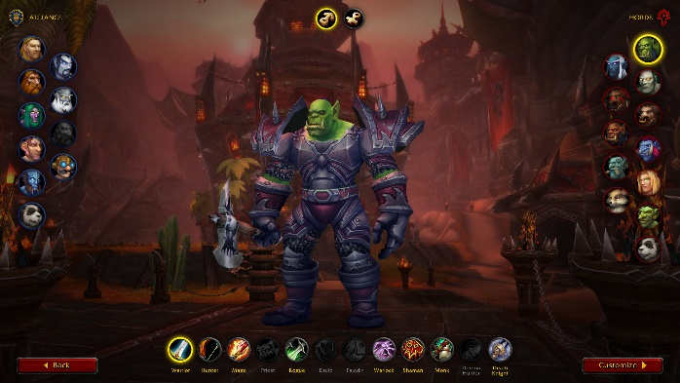I took a lot of inspiration for my project idea from other game’s approaches for character customization. Some that really stood out to me were Divinity Original Sin 2, World of Warcraft and the character creator on the official Dungeons and Dragons website.

Each of these games allow the player to choose between different classes and character origins/races. I liked how the Ui is structured and allows the player to switch between these elements with ease. I especially like the way the UI is laid out in Divinity Original Sin 2, as there is plenty of room for player stats and information about the classes and races.